Healthcare Supply for Migrant Agricultural Workers
Nathan Seto and Anita Alves Pena
REDI Report – July 2025
https://csuredi.org/
- Spatial correlations are low between the numbers of migrant health centers and population concentrations of H-2A workers.
- This is suggestive of gaps in the supply of healthcare services for migrant agricultural workers.
- … (3-5 bullets total)

Overview
The H-2A visa allows agricultural firms, in the face of a labor shortage, to bring in and employ foreign workers on a temporary or seasonal basis. There are currently XXX H-2A workers in the U.S., and the demand for H-2A workers is expected to rise as border policy tightens. Agricultural work has been documented to be dangerous, with disproportionate injuries and illnesses in comparison to alternative occupations (CDC).
Migrant health centers (MHCs) provide specialized medical services for migrant populations. They are equipped to address specific occupational health concerns for migrant agricultural workers, e.g., reactions to pesticides. Analyzing correlations between the numbers of H-2A workers, indicators of environmental risk, and the quantity of MHCs at low geographic levels provides insight into the spatial match, or mismatch, between the availability of specialized healthcare for migrant workers and their families.

Migrant Healthcare Supply
The analysis focuses on the six-state region of Colorado, Montana, North Dakota, South Dakota, Utah and Wyoming that is served by the High Plains Intermountain Center for Agricultural Health and Safety (HICAHS). In total, 12,893 H-2A agricultural workers resided in this region in 2023. There are 56 MHCs across these six states. Colorado has the most with 37 facilities, while South Dakota and Wyoming have zero (Figures 1 and 2).
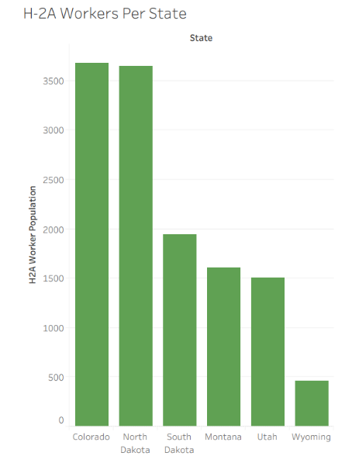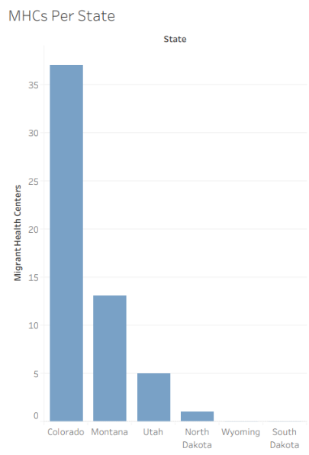
Figure 1: Number of H-2A workers by state Figure 2: Number of MHCs per state

When we compare where migrant farm workers live to where migrant health centers are located, the connection is weak. Statistically, the correlation is just 0.143 on a scale from -1 to 1—close to zero. [On an individual scale by state, On the state level,] we see the following correlations (Wyoming and South Dakota are empty because they have zero MHCs), which are better, but only slightly.
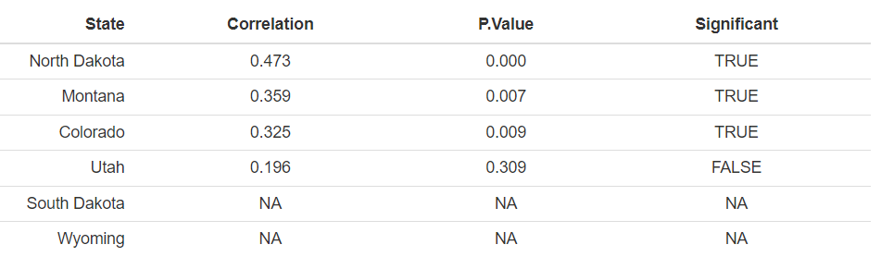
Table 1: Correlation between H-2A workers and MHCs

North Dakota has the highest correlation between H-2A workers and MHCs, and Utah has the lowest. That being said, a coefficient of 0.473, or a coefficient less than 0.5 in general, signifies a relatively weak connection between the two variables. While the correlation is the highest of all six states, it must be noted that there is only a single MHC in North Dakota, settled in Walsh County, for 3,600+ workers and their families. While Walsh County is home to more H-2A workers than any other county in North Dakota, the migrant healthcare supply for the next largest populations, such as those in Pembina, McLean, and Ward counties, is nonexistent.
Colorado has the highest number of MHCs, but the second lowest correlation with the H-2A worker population, another example of the lack of migrant healthcare supply. Adams County has the highest population by county, but only two MHCs. Mesa County is a close second, in terms of the worker population, with no MHCs at all.
In Utah, Utah County has the largest H-2A worker population– almost 3.45 times larger than the second highest– and yet, there are no MHCs within the borders of Utah County, terribly under-serving the priority population.

Exposure to Heat, Fire, and Drought
Many migrant workers live and work in areas with the looming risk of wildfires, heat waves, and droughts. Yet, those same areas often have no MHCs at all. In other words, the people most exposed to climate threats have the least access to care. There are more workers where exposure is higher and limited facilities available nearby. This further signifies the inconsistent supply of healthcare for migrant workers and their families. Correlations between MHCs are low in general, meaning there are not many facilities where exposure is prominent. Below are correlations of the H-2A Population and MHCs against wildfire, heat wave, and drought exposure. There are many notable differences between these associations, such as the difference in correlations with total drought exposure.

Table 2: Correlations between H-2A workers, MHCs with environmental exposure
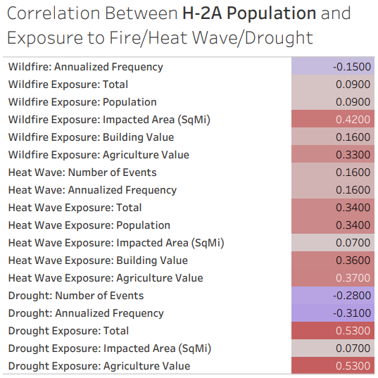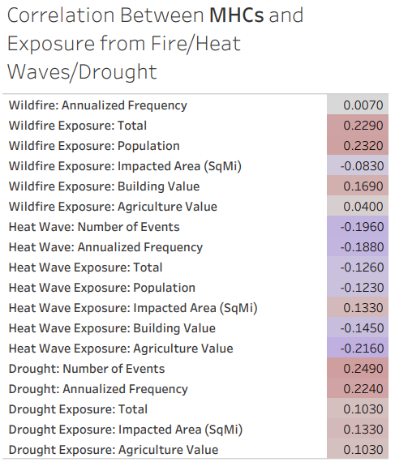
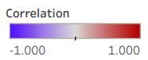

Why is This Important?
This analysis indicates a misalignment between the distribution of MHCs and the concentration of H-2A agricultural workers across six western states. This gap is particularly concerning in places with higher environmental risk factors, such as heat waves, wildfires, and droughts, where healthcare access is especially needed. Given the specialized healthcare needs of migrant agricultural workers, who face occupational and environmental health risks, there is a clear need to reassess and optimize the distribution of MHCs. Areas with high concentrations of H-2A workers and elevated exposure to environmental hazards should be prioritized in future planning and policymaking.
Expansion of MHCs, guided by data on worker population density and climate exposure, would improve the effectiveness and availability of care. Aligning healthcare supply with areas of greatest need will support both public health and the quality of life for the agricultural worker population and their families.

References
“Migrant Health Centers (UDS 2023).” National Center for Farmworker Health, public.tableau.com/app/profile/national.center.for.farmworker.health/viz/MigrantHealthCentersUDS2023/Dashboard1.
“Agriculture Worker Safety and Health.” CDC, https://www.cdc.gov/niosh/agriculture/about/index.html.

